|  |  |  |
| --- | --- | --- |
| **DROPLET ANALYSIS**  **ADrop™**  **Standard Operating Procedures** |  | |
| **Step 1**  Microscope and Camera Set-up | **Step 2**  ImageJ Processing Software | **Step 3**  Droplet Analysis via ADrop™ |

## Equipment set-up and ADrop is for ONLY reading droplets with fluorescence.

## Supplies:

* Leica DM750 Microscope
* Leica Flexacam C3 microscope camera with mount
* Leica Microscope Illuminator 4/20 LBD base
* Cool LED pE-100 Illumination System
* Monitor (sold separately; not required if using laptop)
* Computer mouse with USB dongle (sold separately; not required if using laptop)
* USB flash drive (sold separately)
* (2) USB-c to USB-c cords (sold separately; not required if using laptop)
* Power adapter and cord (sold separately; not required if using laptop)
* HDMI cord (sold separately; not required if using laptop)
* USB Micro-C to USB-A cord (sold separately; only needed if using laptop)

## Equipment Manuals:

* Leica DM750 Microscope
  + https://downloads.leica-microsystems.com/Leica%20DM750/User%20Manuals/Leica_DM750_UserManual_EN.pdf
* Cool LED pE – 100
  + https://[www.coolled.com/wp-content/uploads/2019/06/pE-100-User-manual-Direct-LLG-fit-DOC-012-Iss-7.pdf](http://www.coolled.com/wp-content/uploads/2019/06/pE-100-User-manual-Direct-LLG-fit-DOC-012-Iss-7.pdf)
* Leica Flexacam C3 Microscope Camera

https://[www.leica-microsystems.com/products/microscope-cameras/p/flexacam-c3/downloads/](http://www.leica-microsystems.com/products/microscope-cameras/p/flexacam-c3/downloads/)

### **Microscope Assembly**

* 1. Begin by assembling the microscope, Cool LED light, and camera according to the manufacturer’s manual and instructions provided with the accessory pieces (see page 2 for links to manuals).
  2. Install both magnification lenses, 4x and 10x.
  3. Install the fluorescent filter cube into the filter bar, slide bar into slot, and align the filter bar to the center lens (Fig 1).
  4. Connect all power cords for the microscope and LED system appropriately; power cord directly to microscope and power cord with adapter to LED control box which is also wired to the back of the LED light on the microscope.

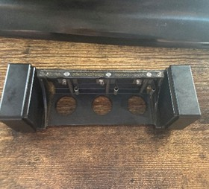

**A**.

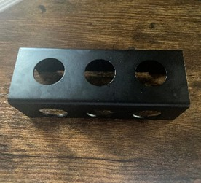

**B.**

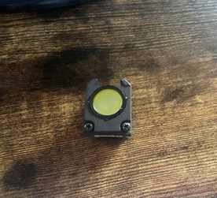

**C.**

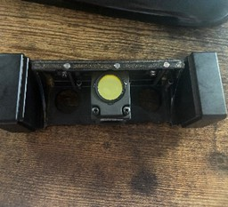

**D.**

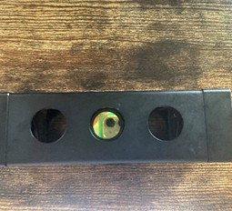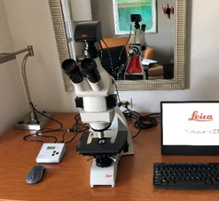

**E.**

**F.**

**Figure 1.** Installing fluorescent cube.

### **Connecting to Independent Monitor**

### Connect the two USB-C cords to the front of the adapter and the additional power cord to the back of the adapter (Fig 2A).

### Connect the camera and microscope to the monitor (requires additional cords, see page 2). To connect the monitor to the microscope/camera system, connect the HDMI-to-HDMI cord to the back of the microscope (into the port labeled “HDMI”, Fig 2B) and connect the other end to the back of the monitor into the port labeled “HDMI-In” (Fig 2C).

### Connect one USB-C cord (already attached to the adapter, Fig 2A) to the “SS” port on the back of the camera mounted on the microscope (Fig 2B). Connect the second USB-C cord (also connected to the adapter, Fig 2A) to the port labeled “USB-C” on the back of the monitor (Fig 2C).

### Connect the included flash drive to the port labeled “Speed” on the back of the camera (Fig 2B).

### A mouse is required to acquire images and maneuver through the program. Insert the mouse dongle into the bottom of the two ports on the top left on the back of the camera (Fig 2B).

# **A. B. C.**

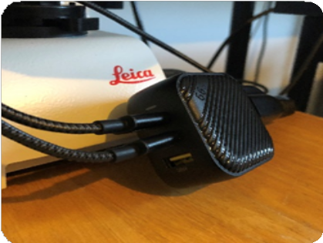

**Figure 2.** (A) Additional power adapter purchased separately; (B) Back of microscope; (C) Back of monitor.

### **2b: Connecting to Computer (laptop)**

2b.1 Connect the USB A to USB micro-C cord to the computer (USB A) and back of camera on the microscope (USB micro-C) into the “SS” plug (Figure 3).

### A. B. C.

**Figure 3**. (A) USB-A end of cord connected into the computer USB-A port. (B) Back of cameral. (C) USB Micro-C end of cord connected to the back of the camera.

1. **Power Set-Up**
   1. To power up the system, plug in all three power cords (microscope, Cool LED system, and monitor).
   2. To power up the system when using laptop, plug in the microscope, Cool LED system and plug the USB-A cord into the computer, the computer powers the camera.
   3. Power on the camera, monitor, and microscope (each has a power button). Do not turn the LED light on yet.
   4. When powering on the camera, a light will flash at the bottom and a beeping noise will follow. The light will turn solid green when the camera is properly connected.
   5. The monitor should display the word “Leica” for a moment and then go to a black/blue screen (this is the camera's image, but there is nothing to view at this time, so it may be black or have a bright blue/white light).
2. **Center the Microscope**
   1. It is important to center the microscope and camera lenses so that the images you see in the microscope are centered within view before each use.
   2. Place the 4x lens in position, look through the microscope, and focus on the blue octagon (Fig 4A).
   3. Once the octagon is in focus (sharp edges), use the two thumb screws to center the octagon on the monitor screen (Fig 4B).
   4. After the octagon is centered, place the 10x lens in position, power off the microscope (turning off the light under the scope using the black switch), and turn on the LED power using the power switch on the Cool LED control box (Fig 4C).
   5. Ensure the LED is at 100%, use the up-arrow button on LED control box to adjust (Fig 4C). The microscope is now ready to use.

**A. B. C.**

**Figure 4.** (A) Centered/focused octagon on monitor; (B) Adjustment screws to center viewpoint on microscope/ octagon on monitor; (C) Cool LED control box.

### **5. Camera Settings with Independent Monitor**

### 5.1 Place a clear glass microscope slide on the specimen stage between the slide grips (Fig 5A). The microscope slide will hold the droplet rods in place during analysis, allowing the rod to be moved easily.

### 5.2 Next, it is important to ensure the settings for the camera are set appropriately. This is done by using the computer mouse and navigating the tabs on the left side of the screen.

### 5.2 To adjust the Camera settings, select the “Camera” tab on the left (Fig 5B). Ensure droplet images are saved in 12MP “TIF” format, "Auto" Brightness setting is switched ON, White Balance "Auto" option is ON, Image Process "Grayscale" and "Negative" are switched OFF, and "Mirror horizontal" Orientation is ON (Fig 5C).

A. B.

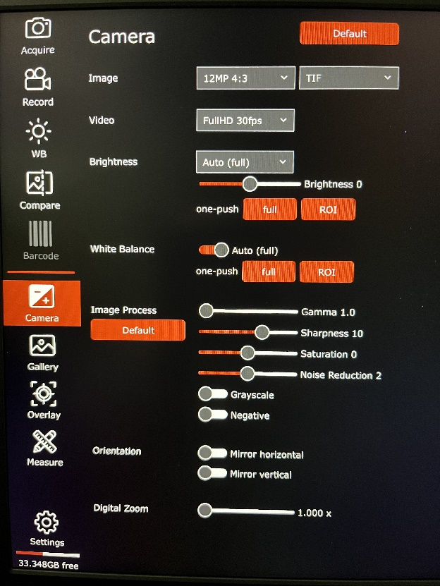

C.

**Figure 5.** (A) Glass microscope slide secured with slide grips; (B) Camera settings displayed on monitor; (C) Mirror horizontal setting.

**5b: Camera Settings when using Laptop**

5b.1: Place a clear glass microscope slide on the specimen stage between the slide grips (Fig 5A). The microscope slide will hold the droplet rods in place during analysis, allowing the rod to be moved without issue.

5b.2: Next, it is important to ensure the settings for the camera are set appropriately. This is done by using the computer mouse pad and navigating the “Leica” icon (program) and opening the program (Fig 6A).

5b.3: In the “Camera” tab on the left, under the “Brightness” tab, ensure “Auto Exposure” is turned **ON** (Fig 6B); under the “White Balance” tab ensure that the White Balance "Auto" option is ON (Fig 6C); under the “Image Process” tab "Grayscale" and "Negative" are switched OFF (Fig 6D); and under the “Orientation” tab ensure the orientation is set to “Mirror horizontal” (Fig 6E).

5b.4: To adjust the image settings, select the “Setting” tab on the bottom left (Fig 6F). Under the “Image” tab, ensure droplet images are saved in 12MP and “TIFF” format.

**A. B.**

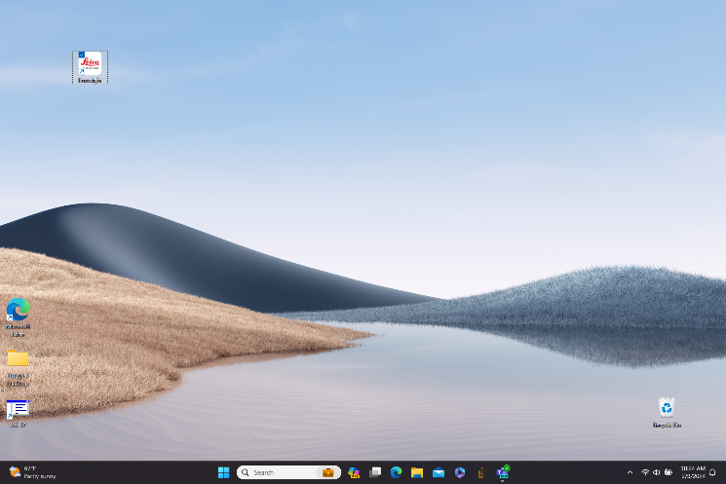

**C. D.**

**E. F.**

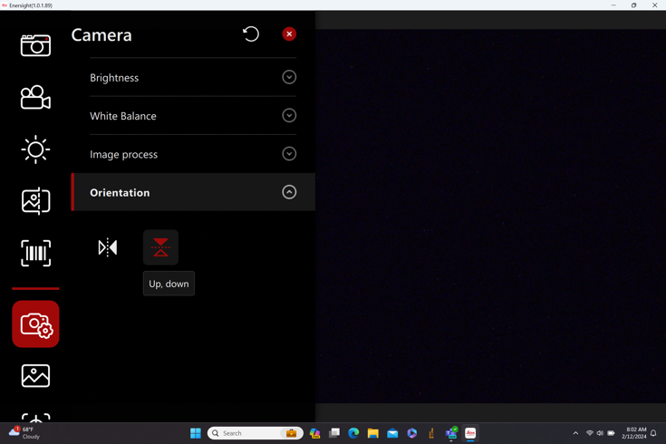

Figure 6: (A) “Leica” icon (program) for opening the program, (B) “Auto Exposure” is turned **ON,** (C) “White Balance”, "Auto" option is ON, (D) “Image Process” tab "Grayscale" and "Negative" are switched OFF, (E) “Orientation” tab set to “Mirror horizontal” (Fig 6E).

### **6. Acquiring Images**

### 6.1: It is important to name the images properly, to do this, in the “Settings” tab, select the “Gallery” tab on the left option panel on the monitor screen. This is where the acquired images will appear and where the folder set-up is located for the images to be saved (Fig 7A). It will be valuable to create the folders needed for the project prior to capturing the droplet images.

6.2a: When using an independent monitor; to add a folder, select the folder icon “New”, name the folder (create separate folders for each replicate), and select "ok" (Fig 7B). The folder will now appear in the gallery. Be sure to have the appropriate folder open where you want the images to be saved as you acquire each image. To navigate through the folders, use the circled-up arrow icon and select the desired folder.

6.2b: When using a laptop monitor, create a folder on the computer (remember its location), then select the icon next to the folder name in the upper left corner (Fig 7C). Select the folder named for that data set.

A. B.

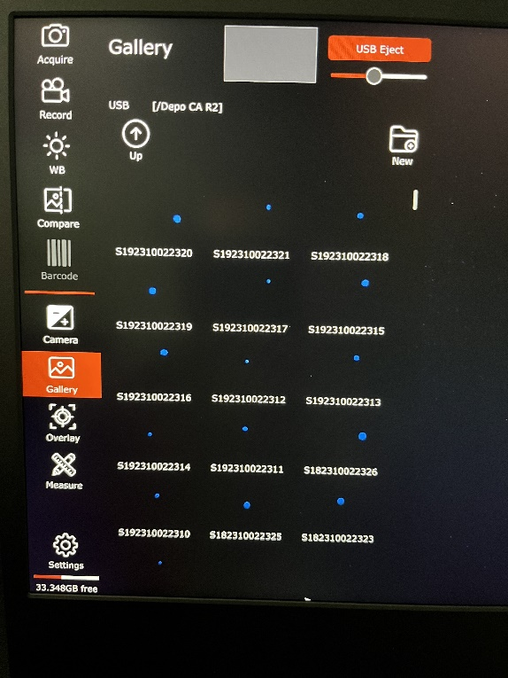

**Figure 7.** IndependentMonitor Screen. (A) Adding folders; (B) "Settings" tab to name images.

C. D.

E. F.

**Figure 7.** Laptop Monitor. (C, D and E) Adding folders; (F) "Settings" tab to name images.

6.3: Before acquiring images, name the set of images (which is associated with the collection station used during the application). Select the “Settings” tab on the bottom left of the screen and then select the “Gallery” tab at the top of the page (Fig 7B for independent monitor and Fig 7F for laptop). Enter the station number in the “Image Name” box. For example, Station 1 (100 feet) should be labeled “S1”, and Station 2 (200 feet) should be labeled S2; this pattern can continue up to 5 stations when using the standard ADrop™.

6.4: To begin acquiring images, place the droplet rod or slide (Teflon tape side up) on the empty microscope slide on top of the specimen table.

6.5: Adjust the table as needed to get the rod under the lens. Adjust the table height so that the rod or slide edges are in view (approximately ¼ inch).

6.6: Use the table adjustments to move the rod under the lens until a fluoresced blue drop is found. Focus in on the drop ensuring the image on the monitor is clear.

6.7: Select “Acquire” on the top left side of the monitor with the mouse to save that image. The camera will make a beep sound and “Image Acquired” will appear on the screen when the capture is complete.

Acquire at least 10 clear droplet images for each station, or enough images to capture approximately 200 droplets. Rename the images appropriately between sampling stations within one replicate. For example, the goal is to have 10 “S1” images, 10 “S2” images, and so on for each station. Remember to change folders between replicates.

6.8: All images are saved on the flash drive inserted into the back of the camera and can be retrieved on a computer.

### **7. Image J**

7.1: Insert the flash drive that was used to save acquired droplet images into the USB port on a computer.

7.2: Open the “d-drive” to view the folders and images acquired using the microscope (Fig 8A). Note that there is automatically a “thumbnail” folder in each image folder, this is needed for ImageJ analysis, DO NOT DELETE!

7.3: Open ImageJ program on the computer (ImageJ plugin provided by VBC), select “plug-in” from the taskbar, select “VBC Software” tab, then select “ADrop 2.4 UV TIF” (Fig 8B). Be sure to have the most recent updated plugin (the most up-to-date ImageJ plugin can be found in the shared folder for download).

7.4: A pop-up window will appear with instructions to select the folder where the images are saved (do not select the “thumbnail” folder). Select the appropriate folder and click “open”.

7.5: ImageJ will begin running. Images will flash on the computer screen as the program conducts the analysis. Once complete, the images will stop flashing. The “Results” file will be saved in the same folder where the images were originally saved.

A. B.

**Figure 8.** (A) Example of file contents saved after images have been acquired; (B) ImageJ task bar with ADrop plugin selected.

### **8. ADrop™ Analysis**

8.1: Login to the ADrop™ cloud app with username and password (https://valentbiosciences.shinyapps.io/ADrop/) (Fig 9B). An error notice will appear on the screen and will remain until a “Results” file is uploaded.

8.2: Select the adulticide product evaluated from the dropdown menu.

8.3: Select “Browse” to upload the “Results” Excel CSV file created by ImageJ after droplets analysis completion (see Step 7.5) (Fig 9A).

8.4: After uploading the “Results” file, graphs and statistics will be generated.

8.5: The "Graphs" tab displays two graphs showcasing the overall volume median diameter (VMD) and numerical median diameter (NMD) across sampling stations (Fig 9C). On each graph, the cumulative volume fraction (CVF) is on the y-axis and the droplet diameter (microns) is on the x-axis. The red horizontal reference line on each graph depicts the VMD 0.5 or NMD 0.5.

8.6: Select the “Stats” tab to view the overall VMD and NMD DV 0.1, DV 0.5, and DV 0.9 (Fig 9D). Droplet parameters (total number of droplets, VMD, NMD, and droplet density) for each individual station are presented in the table below the overall statistics.

8.7: Select the “Download Results” tab to download and save the VMD and NMD graphs in pdf format, and the droplet statistics in an Excel file.

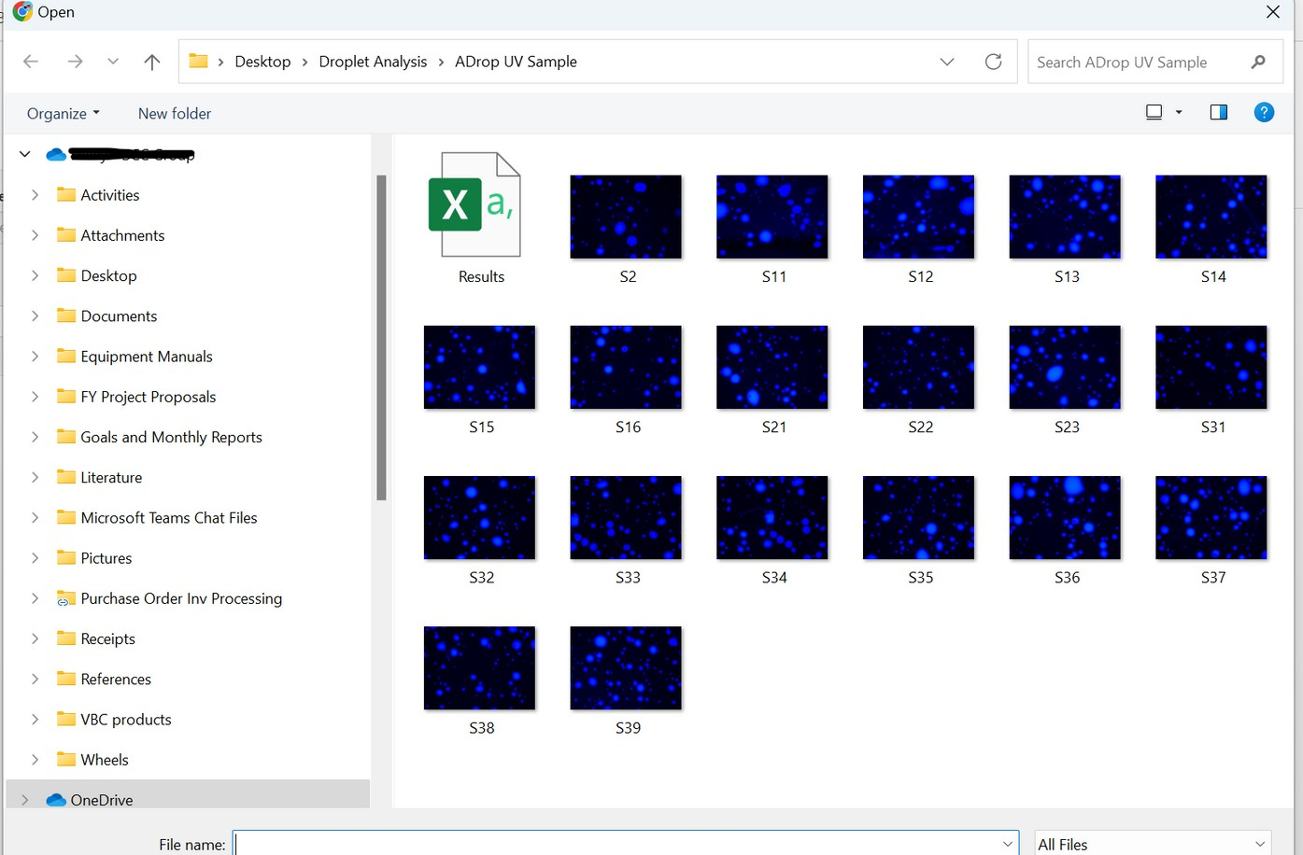

**A.**

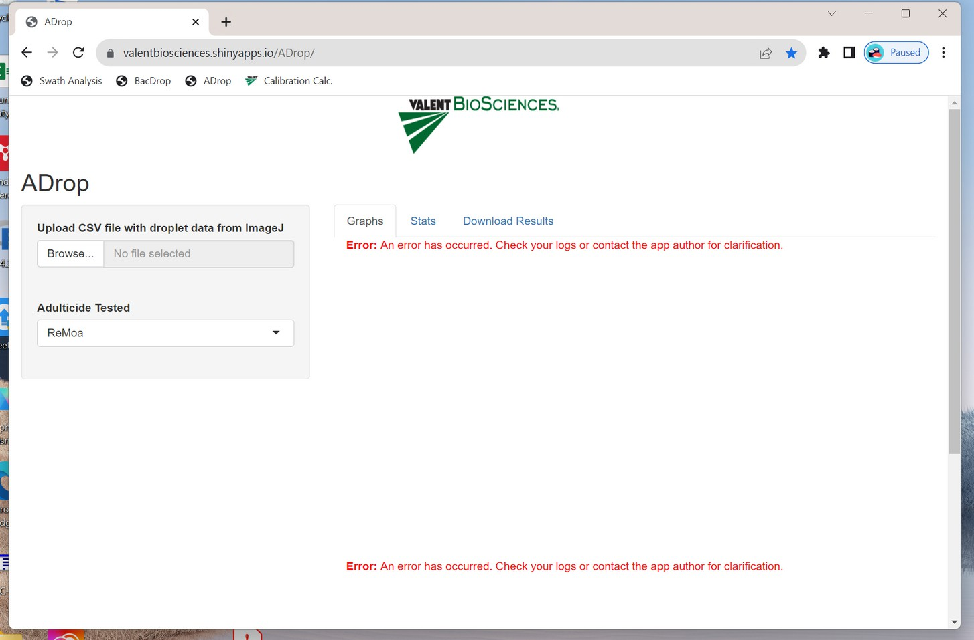

**B.**

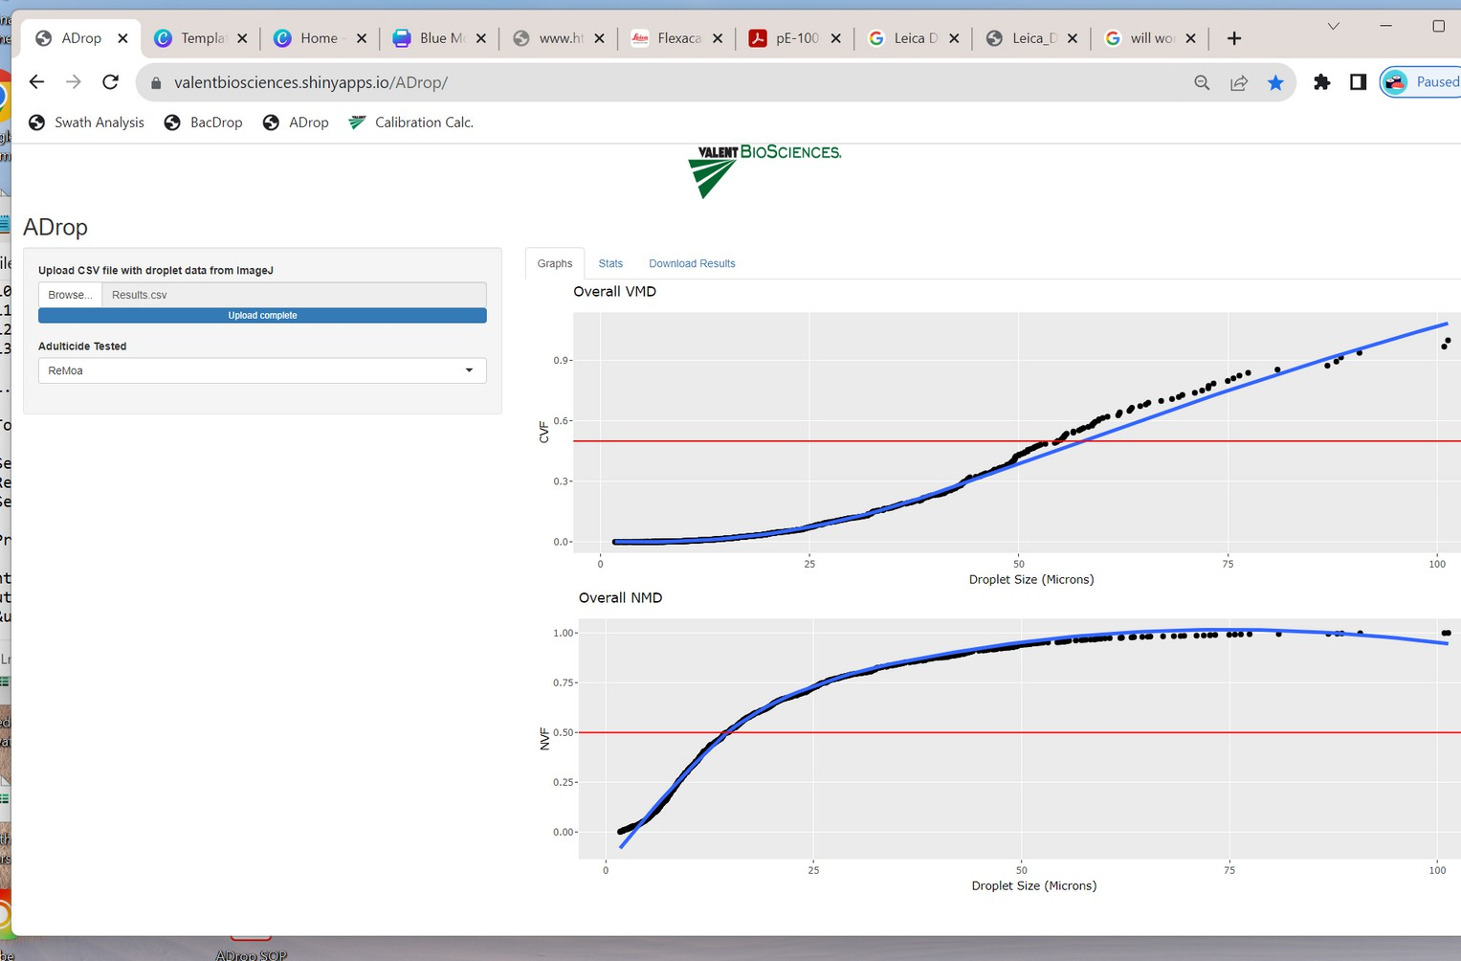

**C.**

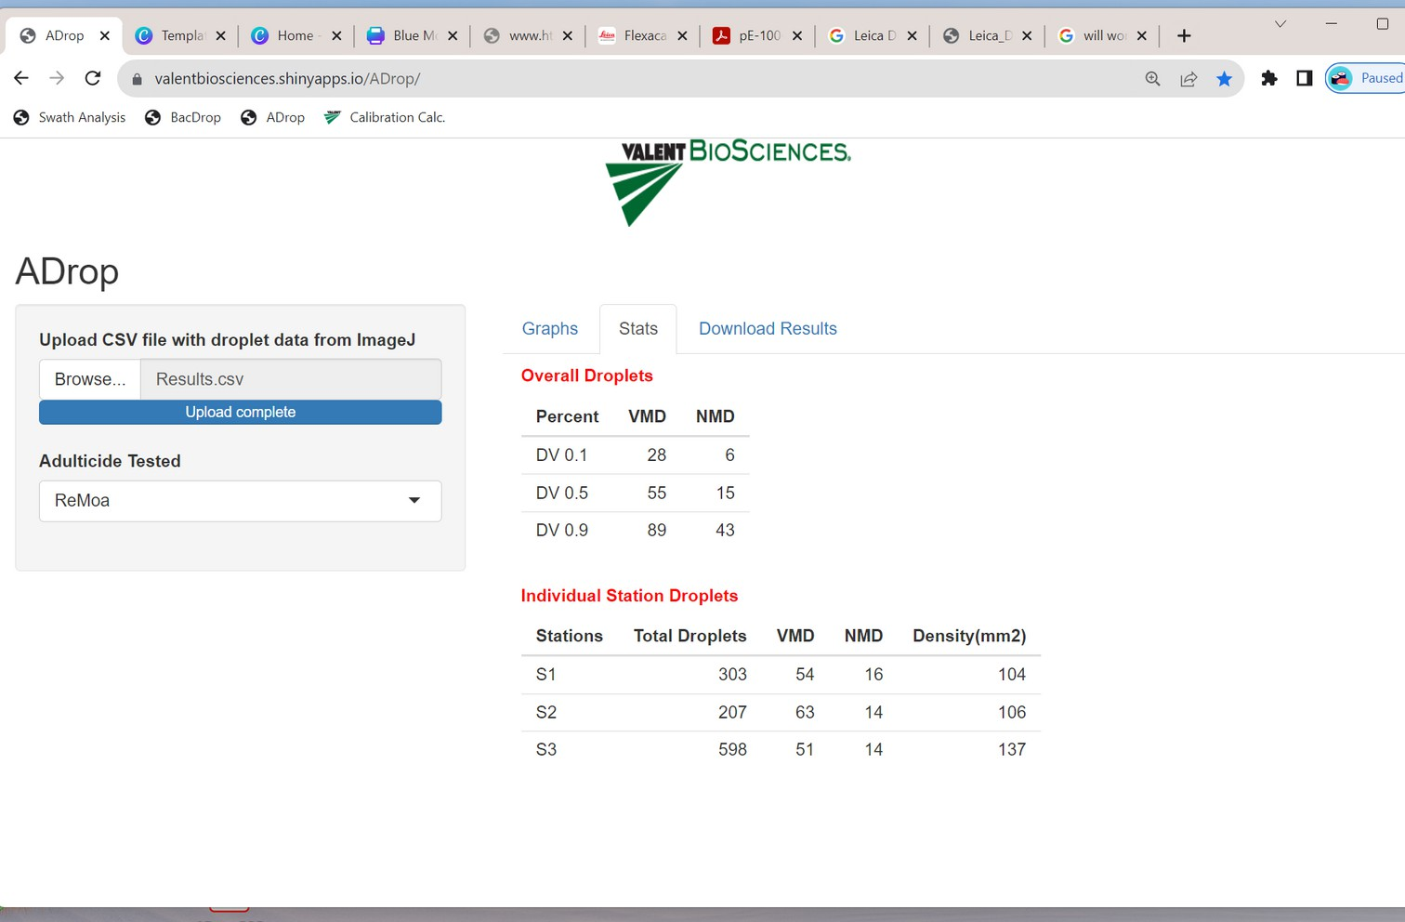

**D.**

**Figure 9.** (A) ImageJ results file to be uploaded to ADrop™; (B) ADrop™ homepage after logging in; (C) Generated graphs; (D) Generated droplet statistics.